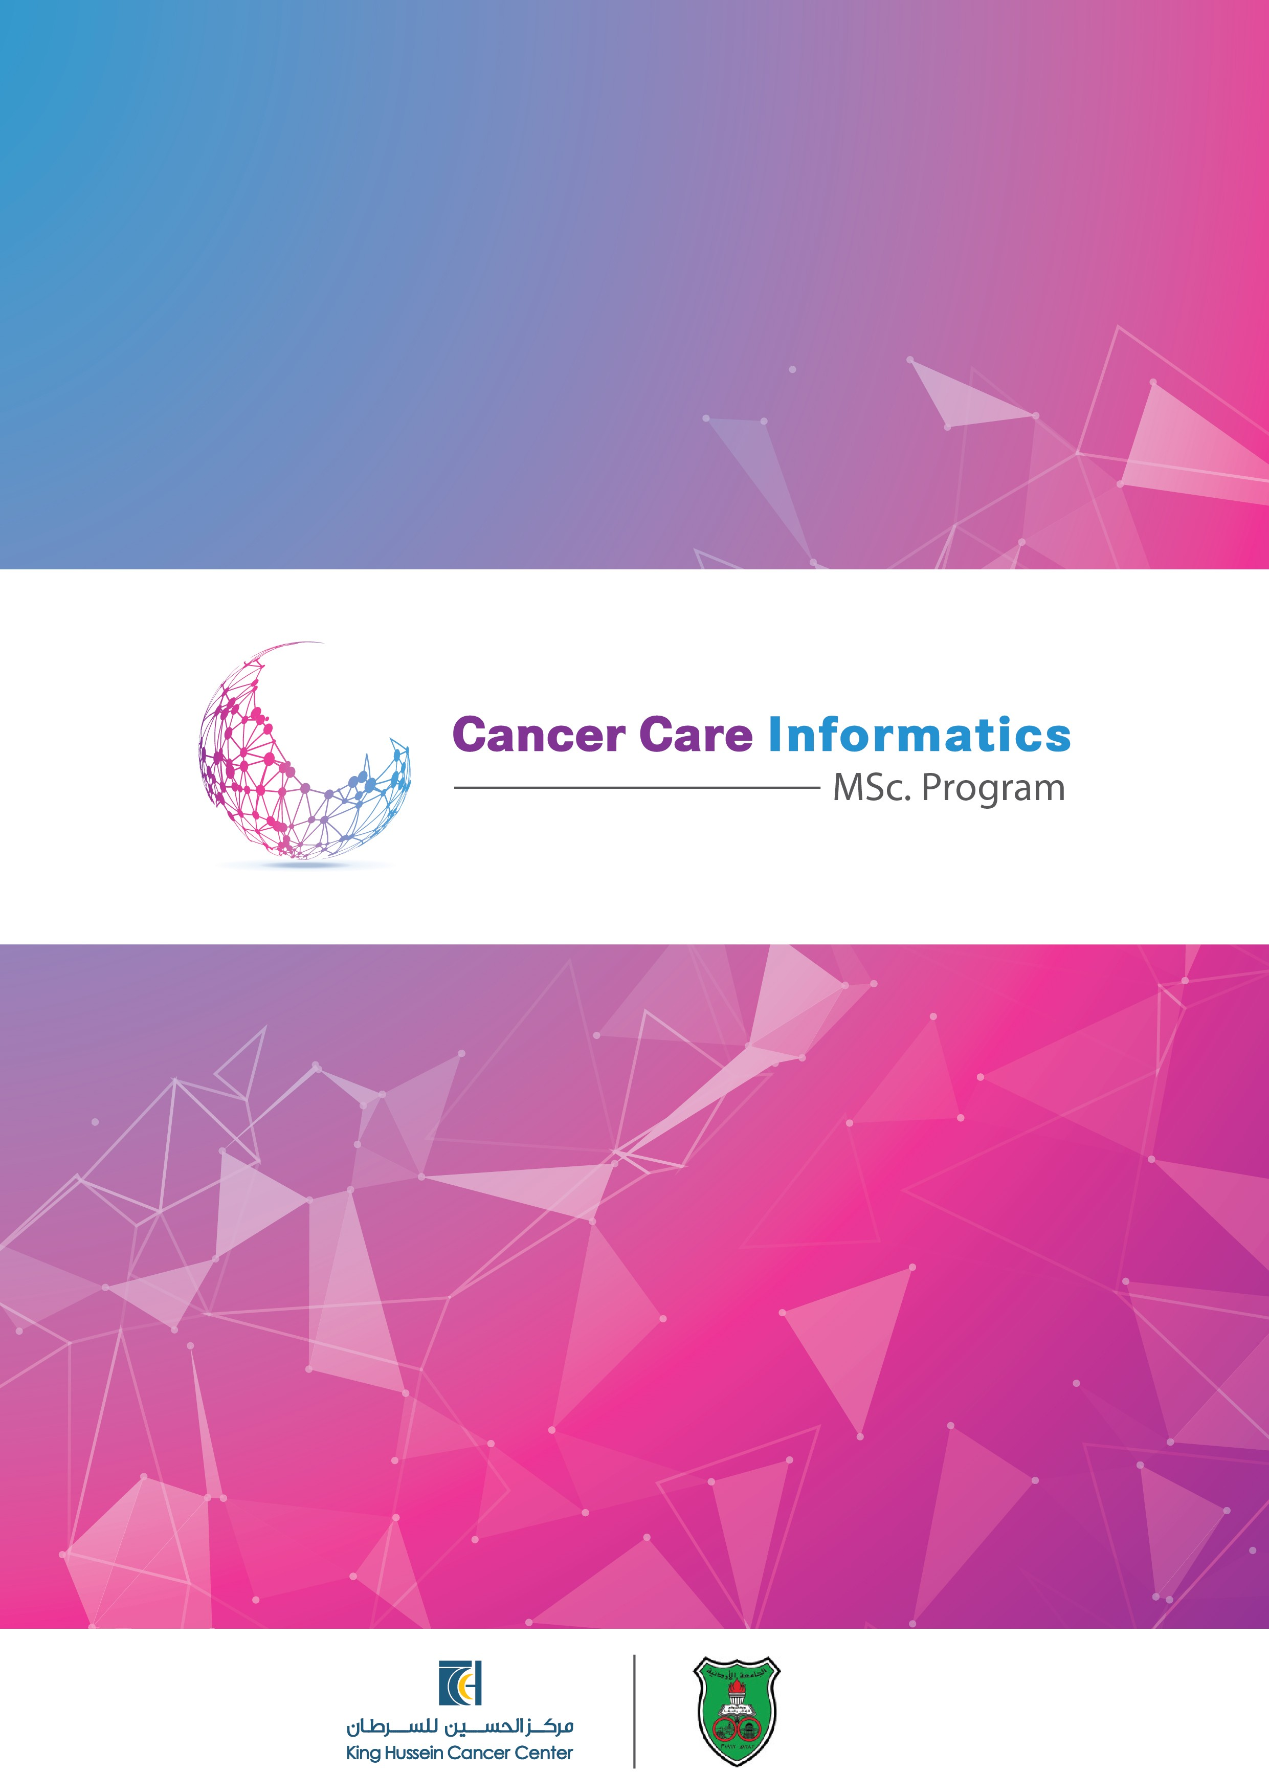

## ABOUT THE PROGRAM

The MSc program in Cancer Care Informatics is the **1st International MSc program**, ***both taught and research***, that holistically empowers the process of cancer care through informatics. **The 1st run of this program started in December 2019** with the current cohort's anticipated completion by July 2021.

**The 2nd program run will start in January 2021.**

**This is a joint program between King Hussein Cancer Center and The University of Jordan.**

This program is aimed at the key stakeholders involved in the process of cancer care to empower their role and duties using an informatics-centric approach, where information strategy and governance; process architectures; requirements engineering; life-long learning; legal, social, ethical and social informatics implications; cancer care data analytics; precision medicine and cancer bioinformatics are amongst the key building blocks of this program.

## PROGRAM AIM

To develop qualified graduates who can employ informatics to holistically empower the process of cancer care in a multidisciplinary cancer care team in order to improve the efficiency and effectiveness of cancer care processes, and the quality of cancer patients’ experience and outcomes of care.

For more information about establishing the discipline of Cancer Care Informatics and the associated on-going research and developments, please visit the online pages of 1st International Conference on Cancer Care Informatics that was jointly organized by King Hussain Cancer Center and the University of the West of England in the period November 19-21, 2018: <https://cancercareinformatics.org/cci/>

## 

## Faculty

The program will be delivered by multi-disciplinary team of academicians and researchers in cancer care and informatics and using state of the art output of PhD research in Cancer Care Informatics. Faculty members are from King Hussein Cancer Center, the University of Jordan, and invited guest lecturers from national and international universities.

The program is co-led by two co-program directors forming the multi- disciplinary leadership of the MSc in Cancer Care Informatics. The co-directors are:

**Mohammed Odeh, PhD**



*Professor of Cancer Care Informatics, Co-director of Cancer Care Informatics,*

*Co-Director of the MSc Cancer Care Informatics Program.*

[*Mohammed.Odeh@sky.com*](mailto:Mohammed.Odeh@sky.com)

**Abdelghani Tbakhi, MD**



*Co-director of Cancer Care Informatics,*

*Co-Director of the MSc Cancer Care Informatics Program, Chairman, Department of Cell Therapy & Applied Genomics.*



**PROGRAM LEARNING OUTCOMES**

* Critically understand the problems and constraints that may confront cancer care professionals, and develop the necessary underlying informatics knowledge and cognitive skills to resolve them;
* Develop critical understanding of the role of information strategy, process architecture, usability and quality governance, and requirements engineering in the holistic empowerment of the process of cancer care for both the patient and the cancer care organization;
* Apply cancer care principles and processes with efficacy and efficiency empowered by informatics in legal, social, ethical, and professional contexts nationally and internationally;

 • Demonstrate critical understanding of the role of cancer care decision making processes and their dependence on timely, reliable, complete, consistent, and correct information considering cancer care governance, the variability of treatment options, associated costs and the required patient support services such as palliative care, nutrition, counselling support and rehabilitation; and

* Conduct and appraise advanced research in particular areas of cancer care using research methods, frameworks, and tooling for cancer care informatics

## PROGRAM STRUCTURE

The program is composed of **36 credit hours,** 27 credit hours of taught elements and 9 credit hours for the MSc Dissertation / Thesis.

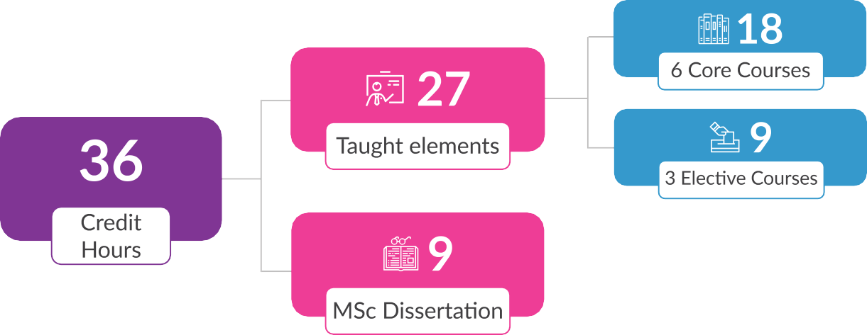

The following are the core **18 credit hours** spread over 6 courses, 3 credit hours each.

* Research Methods and Tooling for Cancer Care Informatics
* Requirements Engineering for Cancer Care Informatics
* Information Strategy and Architecture for Cancer Care Informatics
* Usability and Quality Governance for Cancer Care Informatics
* Legal, Social, Ethical and Professional Issues for Cancer Care Informatics
* Data Analytics for Cancer Care Informatics

There are **9 credit-hours of elective courses** and these are spread over 3 courses, 3 credit hours each. Students can choose amongst the possible offered courses such as:

* *Economics of Cancer Care Informatics*
* *Integrated Case Studies: Personalized / Precision Medicine*
* *Integrated Case Studies: Practice Management Systems*
* *Integrated Case Studies: Cancer Surveillance Systems*
* *Integrated Case Studies: Clinical Trials Management Information Systems*
* *Integrated Case Studies: Clinical Decision Support Systems*
* *Integrated Case Studies: Digital Cancer Genetic Counselling*
* *Integrated Case Studies: Electronic Medical Records System (EMRS) and their role.*
* *Integrated Case Studies: Personalized / Precision Medicine*
* *Integrated Case Studies: Ancillary and Supportive Systems.*

**PROGRAM DELIVERY**

Teaching on this program will be delivered both Face-to-Face and Online with Blended Learning in Block and Traditional modes over two-three semesters.

Thus, with this MSc program cancer care professionals will not need to leave their jobs or working places for long duration because of the mixed mode delivery being Online, Face-to-Face with embedded Block mode delivery to some of the program courses. This MSc program delivery will be adjusted to take consideration of the enrolled students’ needs for the particular program cohort. Teaching will start with induction in January 2021.



# 01

**02**

Assessment of coursework and exams will be conducted at the end of the teaching semester and will follow the University of Jordan assessment rules and guidelines as dictated by their Colleague of Graduate Studies and King Hussein Cancer Academy of King Hussein Cancer Center.

# 03

Students will start their MSc dissertation / thesis unless when they have studies the first three core courses of this program.

**04**

Each student on the MSc Dissertation / thesis will be allocated one director of studies and one co-supervisor or more in their areas of research interest and specialization.

# 05

An Annual MSc Examination board will be formed and led by King Hussein Cancer Academy, the University of Jordan (King Abdullah II School of Information Technology) and national/international external examiners. This board will meet annually in pre-announced dates to approve awarding degrees subject to the University of Jordan rules and regulations for Graduate Studies.

**ENTRY REQUIREMENTS**

# 01

Applicants must have a first degree in either of the following disciplines:

1. Healthcare professions: medicine, nursing, pharmacy, biomedical sciences, radiography, hospital and patient management, Medical technologist, and Biotechnology and Genetic engineering, etc.
2. Informatics graduates in Computer Science, Software Engineering, Business/Computer Information Systems; or
3. Selected engineering and other related disciplines such as but not limited to: industrial engineering.

**02**

Applicants must have the equivalent of a GPA of 2.75/4.00 or above in their first degree.

# 03

Applicants will need to achieve preferably IELTS 6.5 or 90 in TOEFL IBT before starting the MSc program.

Offers to study on this program will be based on satisfying the above entry requirements. However, an interview may be required, as decided by the MSc CCI co-directors. Places are limited to 15-15 candidates for the 2018-19 academic year.

**Fees:** 200 JD/ Credit hour Jordanian (Total 7,200 JD) 500 US$/ Credit hour Non-Jordanian (Total 18.000 US $)





**How to Apply?**

Please click here to download the application form, fill it and email to [MA.14508@khcc.jo](mailto:MA.14508@khcc.jo)

**Contact Us:**



King Hussein Cancer Academy of King Hussein Cancer Center



P.O. Box 1269, Al-Jubeiha, Amman 11941, Jordan



Telephone No: +962 5300 460 ext. 2230 ,



2232, 7473

Email: [MA.14508@khcc.jo](mailto:MA.14508@khcc.jo), [AFawaz@KHCC.JO](mailto:AFawaz@KHCC.JO)

